Written Exam Question from Grace Wilkinson

**Open book, 5 hours maximum**

Green Valley Lake is a 156 hectare reservoir located in Union County, Iowa. The reservoir was constructed in 1952 and has been subjected to numerous restoration activities including fishery renovations, shoreline stabilization and dredging. The most recent restoration, which began in 2008, included removal of rough fish (mainly common carp), targeted dredging along the west arm of the reservoir, and the construction of in-lake silt dikes at both the east and west inlets. Since this restoration, the reservoir’s water quality has gone from bad to dramatically worse with phosphorus concentrations almost tripling (Figure 1).

I have provided the Ambient Lake Monitoring data for Green Valley Lake from 2000-2019 and a diagram of the lake (Figure 2). Note that during the restoration years, 2008-2010, the lake was not sampled. Using your limnological knowledge (hint: think about physical, chemical, *and* biological processes), please do the following:

1. Generate at least 3 hypotheses as to the mechanisms driving the change in water quality in Green Valley Lake, before and after the 2008-2010 restoration. Please note, the hypotheses do not have to be mutually exclusive.
2. Use the historical Ambient Lake Monitoring data to evaluate your hypotheses, where feasible. You may also pull in other data sources, if available, although this is not required. If data are not readily available, describe what historical data sets you would like to acquire and briefly how you would analyze them to evaluate your hypotheses.
3. Based on the hypotheses you’ve generated and fully (or partially) evaluated, design a study to determine the cause of the change in water quality in Green Valley Lake following the 2008 restoration. Please briefly justify the study design. The overall goal of your study is to identify the source(s) of the water quality problem and provide management recommendations to the state and local managers.

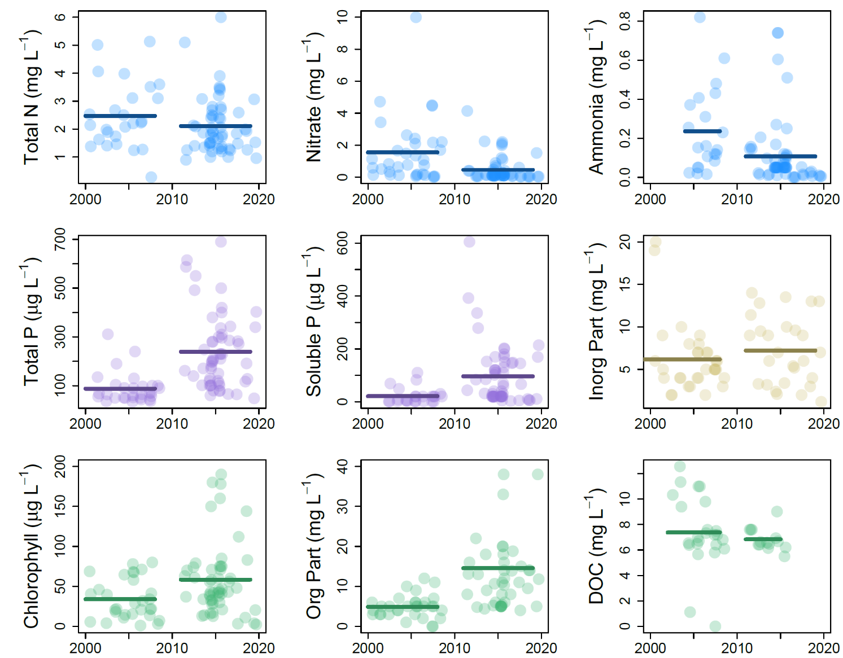

*Figure 1. Total phosphorus concentrations in Green Valley Lake from 2001 – 2019.*

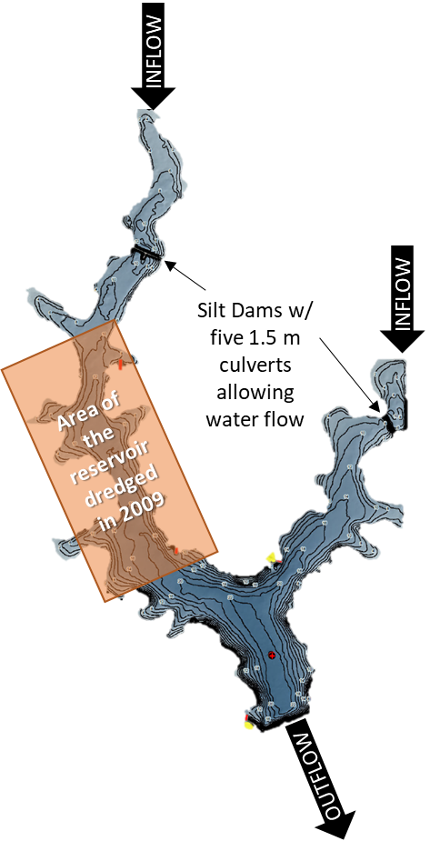

***Figure 2****. Bathymetric map of Green Valley Lake and an indication of the two major inlets and the outlet. The silt dams, which were constructed in 2008, block flow from the inlets into the main portion of the lake except for the water flow through 5 culverts in each dam. A portion of the western arm was dredged in 2009 (orange box) and the Ambient Lake Monitoring samples have been taken at the red cross, indicated on the map, near the dam.*